Analysis Document

Team Members: [Youssef Ibrahim, Roaya Youssef, Karem Salem, Roaa Sameh, Ahmed Mahmoud]

Group - 2 | School Project

**SwiftBus**

2025

**Bus Booking System**

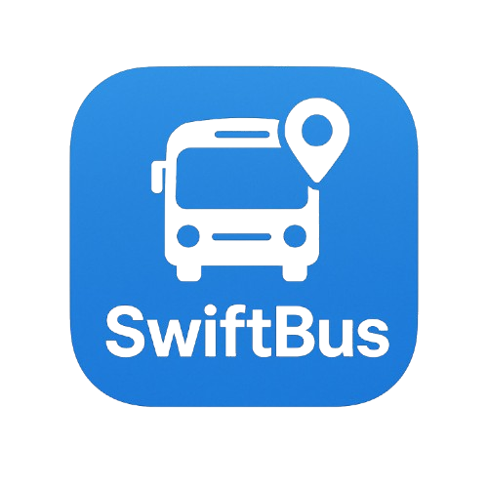

**Table of content:**

**Chapter 1**

1 –introduction

2 –purpose

**3** –scope

4 –objectives

5 –user roles

6 –user stories

7 -usecasediagram

8 –usecasedescription

9 –ActivityDiagram

**Table of content:**

**Chapter 2**

1 - Class Diagram

2 - Object Diagram

3 – Sequence Diagram

4 – UI/UX Design



**Chapter 1**

**Analysis**

**1 - Introduction**

**------------------------**

**This document outlines the system analysis for a Trip Booking and**

**Management Platform. The platform is designed to simplify the process**

**of browsing, booking, and managing travel appointments for end users**

**while providing powerful administrative tools for system administrators.**

**2 - Purpose**

**----------------------**

**The purpose of this system is to streamline the booking process for travel**

**trips, enabling users to find and book suitable trips easily, manage them**

**bookings, and provide feedback. At the same time, the platform**

**empowers administrators to manage trip schedules, handle bookings**

**efficiently, and maintain high service quality through direct interaction**

**with user data and feedback.**

**3 - Scope**

**-------------------**

**The system covers the full lifecycle of trip booking and management,**

**from user registration and trip search to ticket generation and feedback**

**collection. It includes functionalities for both end users (travelers) and**

**administrative staff. Key features include:**

* **User account creation and login.**
* **Viewing and filtering trips.**
* **Submitting and managing booking requests.**
* **Downloading approved trip tickets in PDF format.**
* **Providing feedback and rating trips.**
* **Admin management of trips, users, and destinations.**
* **Admin approval workflow for booking requests.**
* **Automated email notifications for booking status.**
* **Feedback monitoring and service quality evaluation.**

**System Objectives**

**---------------------------------------**

* **To provide an intuitive platform for users to book and manage their travel plans.**
* **To allow administrators full control over trip scheduling, destination management, and user bookings.**
* **To automate notifications and documentation such as PDF tickets and emails.**
* **To support continuous improvement through user feedback and ratings.**
* **To ensure secure access and protect sensitive booking data**



**5 - User Roles**

**----------------------**

#### 🔹 User (Traveler)

* **Register and log into the platform.**
* **Search, filter, and view available trips.**
* **Submit trip booking requests.**
* **Track the status of submitted bookings.**
* **View and manage booking history.**
* **Download PDF tickets for approved bookings.**
* **Rate trips and submit feedback.**

#### 🔹 Admin (Administration)

* **Securely log into the admin dashboard.**
* **Add, edit, or delete trip appointments.**
* **Manage destinations and trip schedules.**
* **View and manage user accounts.**
* **Manually add users (e.g., for group bookings).**
* **Approve or decline trip booking requests.**
* **Trigger email notifications to users on request status.**
* **Generate and download PDF tickets for confirmed trips.**
* **Access and evaluate user feedback and trip ratings.**

**6 - User Stories**

**-----------------------**

#### 🔹 As a User:

* **I want to create an account or login, so I can use the platform.**
* **I want to view all available trips, so I can choose a suitable one.**
* **I want to book a trip by submitting a request.**
* **I want to track my booking status, so I know if it is approved or declined.**
* **I want to view my booking history for reference.**
* **I want to search and filter trips by destination, date, time, to quickly find the right trip.**
* **I want to download a PDF ticket after my booking is approved, so I can use it for travel.**
* **I want to give feedback and rate trips, so I can share my experience with others.**

#### 🔹 As an Admin:

* I want to **login securely**, so only authorized staff can access admin tools.
* I want to **add, edit, and delete trip appointments**, so I can manage the schedule.
* I want to **add, edit, and delete destinations**, to keep them up to date.
* I want to **view all users**, to manage the system usage.
* I want to **add users manually**, for example, for corporate or group bookings.
* I want to **see all trip booking requests from users**.
* I want to **approve or decline trip requests** based on seat availability or policies.
* I want to **trigger automatic email notifications** when a booking request is approved or declined.
* I want to **generate and download PDF tickets** for confirmed bookings.
* I want to **see user ratings and feedback** to evaluate service quality and improve it.

**7 – Use Case Diagram**

**---------------------------------**

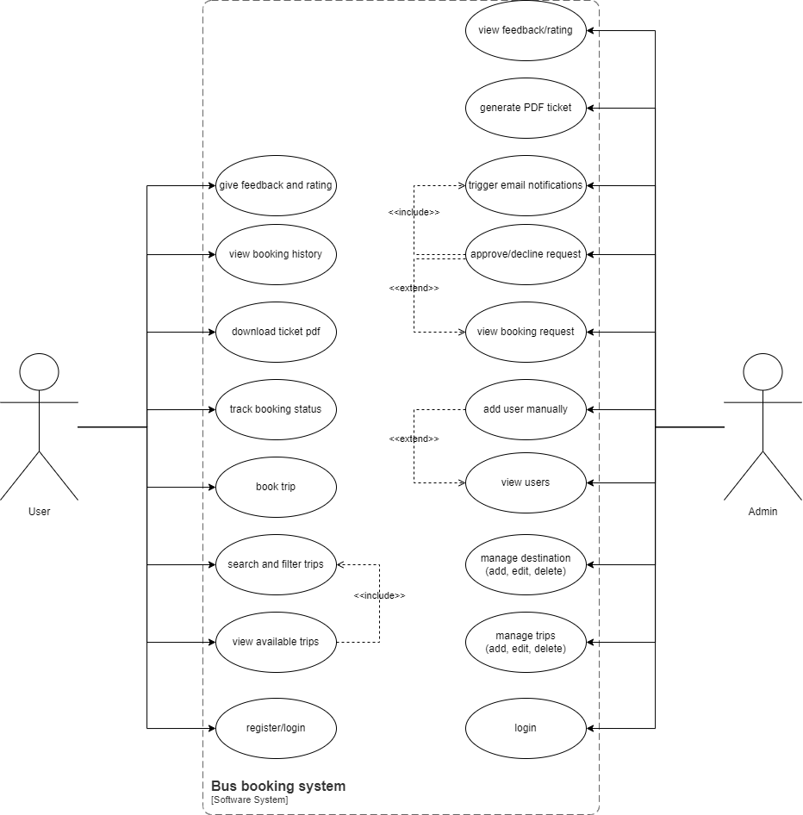

**8 – Use Case Description**

**-------------------------------------**

* register/login

|  |  |
| --- | --- |
| Use case name | register/login |
| Use case description | Allows a user or admin to access the platform by creating an account or logging in. |
| actors | users/admin |
| Preconditions | User or Admin must have account credentials. |
| Postconditions | User/Admin is authenticated and redirected to their dashboard. |
| Main Flow | 1. Open the login or registration page.  2.enter credentials or register new account.  3.system verify credentials  4.redirect to dashboard if successful. |
| Exception flow | Invalid credentials, server errors, or duplicate registration. |

* View Available Trips

|  |  |
| --- | --- |
| Use Case Name | View Available Trips |
| Description | Users can browse the list of trips available for booking. |
| Actors | User |
| Preconditions | User is logged in. |
| Postconditions | List of trips displayed to the user. |
| Main flow | 1. User selects "View Trips".  2.system fetches and displays available trips. |
| Exception Flow | Network issues or no trips available. |

* Search and Filtering Trips

|  |  |
| --- | --- |
| Use Case Name | Search & Filter Trips |
| Description | Allows users to search or filter trips based on criteria. |
| Actors | User |
| Preconditions | User is logged in. |
| Postconditions | Display of filtered search results. |
| Main flow | 1. User inputs destination, date, or time.  2.system filter trips  3.results are shown |
| Exception Flow | No trips match the criteria, or input is invalid. |

* Book Trips

|  |  |
| --- | --- |
| Use Case Name | Book Trip |
| Description | Allows users to book a trip from the list. |
| Actors | User |
| Preconditions | User is logged in. Trips are available. |
| Postconditions | Booking request submitted. Status set to pending. |
| Main Flow | 1. User selects a trip.  2.click “book trip”.  3.system save booking as pending. |
| Exception Flow | No seats available, trip already full, or server error during booking. |

* Track Booking Status

|  |  |
| --- | --- |
| Use Case Name | Track Booking Status |
| Description | Allows users to see if their booking was approved or declined. |
| Actors | User |
| Preconditions | User has made a booking. |
| Postconditions | Display of booking status. |
| Main Flow | 1. User opens booking status page.  2.system shows current status. |
| Exception Flow | Booking not found or server error. |

* Download Tickets PDF

|  |  |
| --- | --- |
| Use Case Name | Download Ticket |
| Description | Users can download a PDF ticket after approval. |
| Actors | User |
| Preconditions | Booking is approved. |
| Postconditions | Ticket PDF downloaded. |
| Main flow | 1. Booking is approved.  2.user click” download ticket”.  3.PDF is generated and downloaded. |
| Exception Flow | Booking not approved, ticket generation failed, or download error. |

* View Booking History

|  |  |
| --- | --- |
| Use Case Name | View Booking History |
| Description | Users can view the history of all bookings. |
| Actors | User |
| Preconditions | User is logged in. |
| Postconditions | Display of all previous bookings. |
| Main Flow | 1. User navigates to booking history.  2.system fetches and shows past booking. |
| Exception Flow | No booking history found or data retrieval error. |

* Give Feedback and Rating

|  |  |
| --- | --- |
| Use Case Name | Give Feedback & Rating |
| Description | User gives feedback or rates a trip. |
| Actors | User |
| Preconditions | User has completed a trip. |
| Postconditions | Feedback is saved and visible to admin. |
| Main flow | 1. User navigates to feedback page.  2.enter rating and comments.  3.system saves feedback. |
| Exception Flow | Invalid input or feedback submission failed. |

* Manage Trips

|  |  |
| --- | --- |
| Use Case Name | Manage Trips |
| Description | Admin can add, edit, or delete trip appointments. |
| Actors | Admin |
| Preconditions | Admin is logged in. |
| Postconditions | Trip data updated. |
| Main flow | 1. Admin opens trip management panel.  2.add/edit/delete trips.  3.system update the trip. |
| Exception Flow | Database error or invalid data entered. |

* **Manage Destination**

|  |  |
| --- | --- |
| Use Case Name | Manage Destinations |
| Description | Admin manages the list of destinations. |
| Actors | Admin |
| Preconditions | Admin is logged in. |
| Postconditions | Destinations updated. |
| Main Flow | 1. Admin opens destination panel.  2.add/edit/delete destination.  3.system update the list. |
| Exception Flow | Database failure or input validation error. |

* View Users / Add users Manually

|  |  |
| --- | --- |
| Use Case Name | View/Add Users |
| Description | Admin views or manually adds users. |
| Actors | Admin |
| Preconditions | Admin is logged in. |
| Postconditions | User data added or displayed. |
| Main Flow | 1. Admin navigates to user panel.  2.view users or fill in the new user form.  3.system saves or displays data. |
| Exception Flow | User already exists, invalid data, or database issues. |

* View and process booking request

|  |  |
| --- | --- |
| Use Case Name | View & Process Booking Requests |
| Description | Admin views booking requests and approves/declines them. |
| Actors | Admin |
| Preconditions | User has submitted a booking. |
| Postconditions | Booking status updated. |
| Main Flow | 1. Admin opens booking requests.  2.reviews and takes actions.  3.status is updated accordingly. |
| Exception Flow | Booking not found, or status update fails. |

* Trigger Email notification

|  |  |
| --- | --- |
| Use Case Name | Trigger Email Notification |
| Description | Sends email to user based on booking status. |
| Actors | Admin |
| Preconditions | Admin updates booking status. |
| Postconditions | Email sent to user. |
| Main Flow | 1. Admin updates request status.  2.system sends email. |
| Exception Flow | Email server not responding or invalid email address. |

* Generate PDF Ticket

|  |  |
| --- | --- |
| Use Case Name | Generate PDF Tickets |
| Description | Admin generates PDF ticket for approved booking. |
| Actors | Admin |
| Preconditions | Booking is approved. |
| Postconditions | PDF ticket is generated. |
| Main Flow | 1. Admin opens booking.  2.click “generate ticket”.  3.PDF is created. |
| Exception Flow | PDF generation fails or file download error. |

* View Feedback and Ratings

|  |  |
| --- | --- |
| Use Case Name | View Feedback & Ratings |
| Description | Admin reviews feedback left by users. |
| Actors | Admin |
| Preconditions | User has submitted feedback. |
| Postconditions | Admin can see all feedback. |
| Main Flow | 1. Admin navigates to feedback panel.  2.views user's ratings and comments. |
| Exception Flow | No feedback submitted or data fetch failure. |

**9 – Activity Diagram**

**------------------------------**

User Scenario

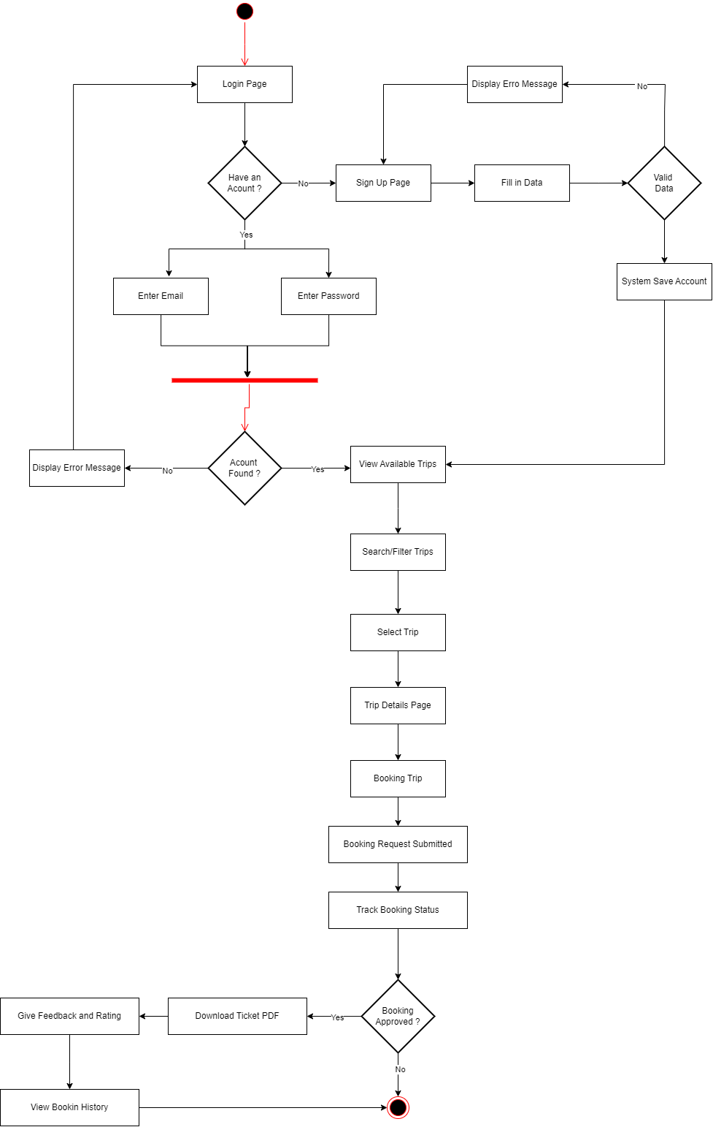

Admin Scenario

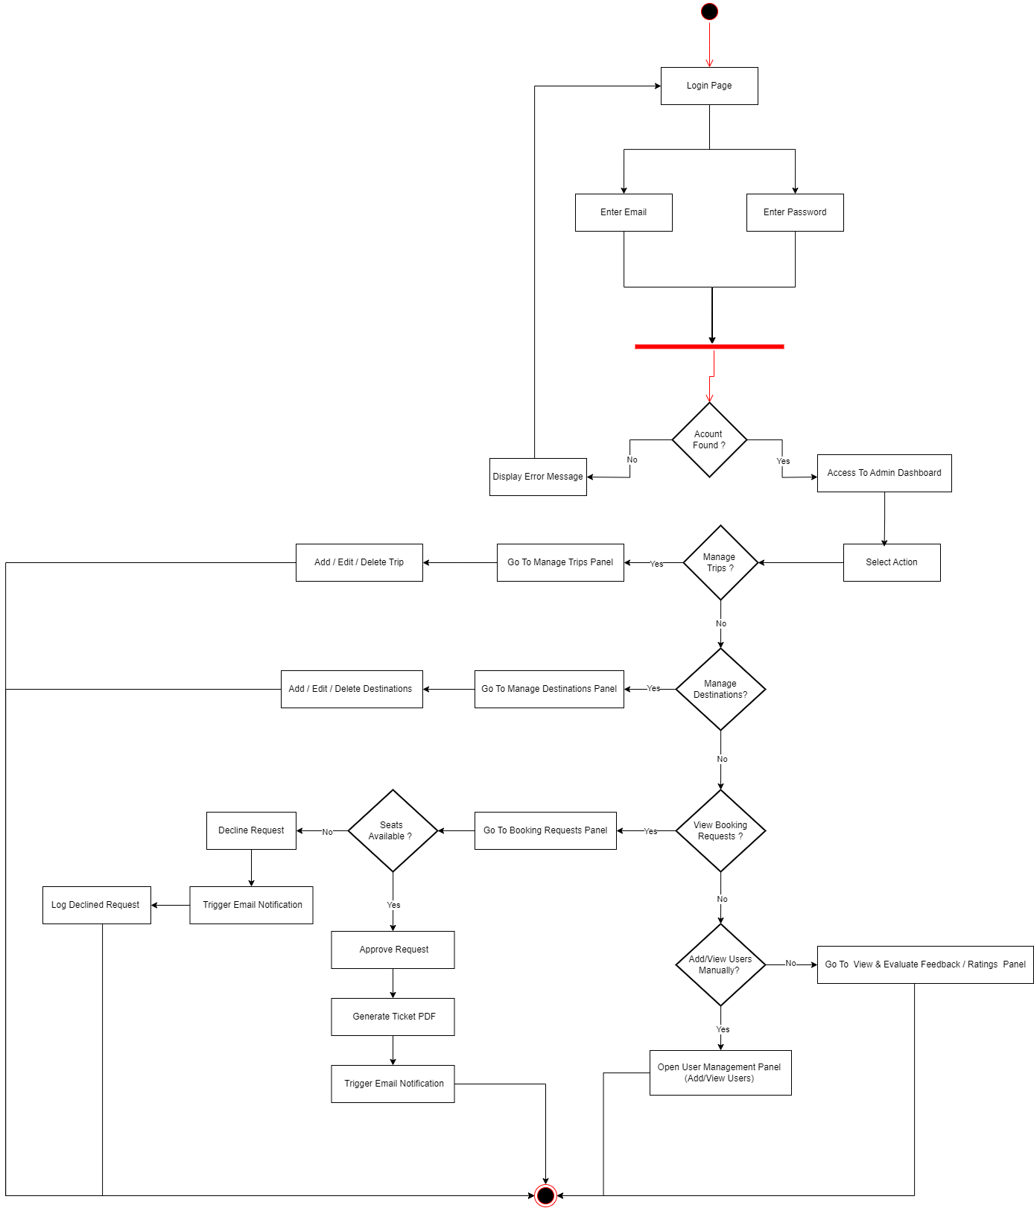

**Chapter 2**

**Design**

**1 – Class Diagram**

**-----------------------------------**

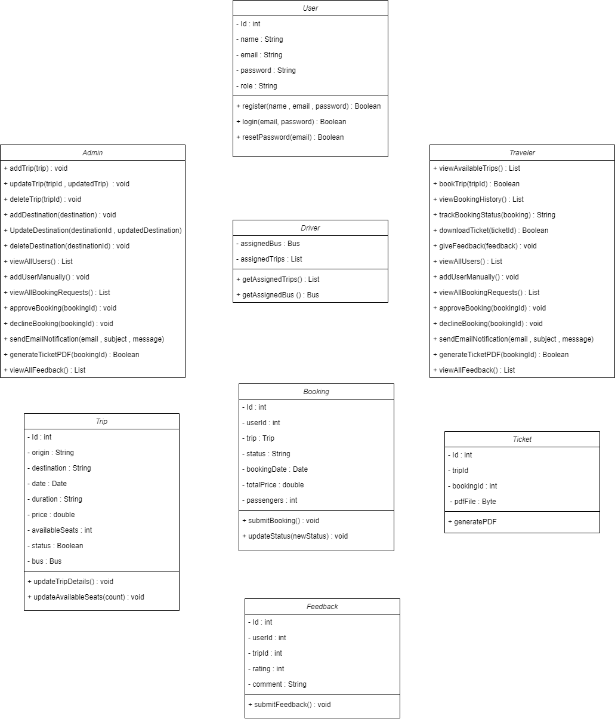

**2 - Object Diagram**

**----------------------------------**

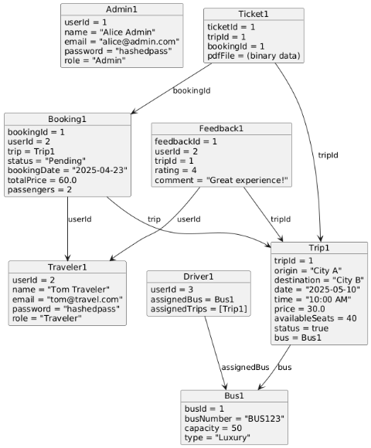

**3 - Sequence Diagram**

**----------------------------------------**

* Login / Register

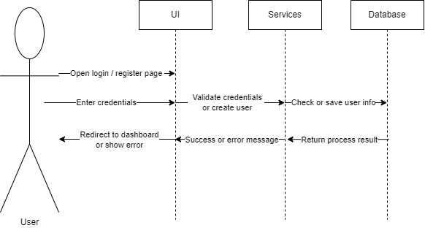

* Show Available Trips

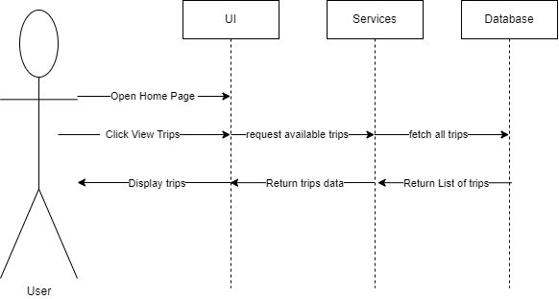

* Search Filtering Trips

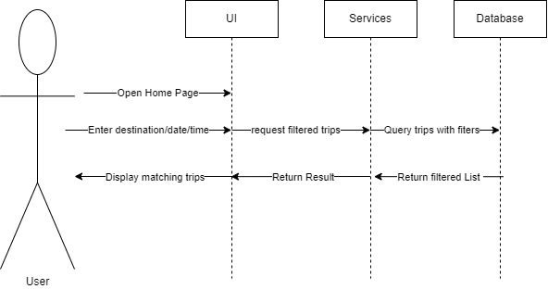

* **Booking Trip**

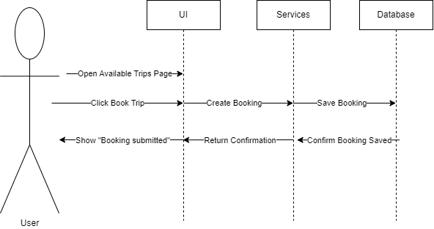

* Track Booking Status

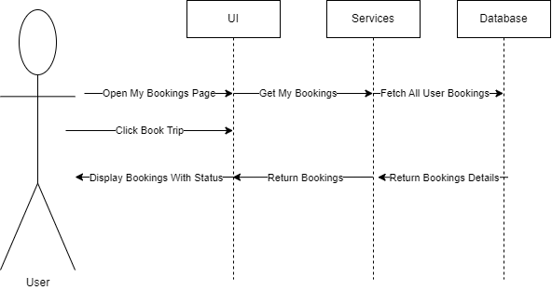

* Download Ticket

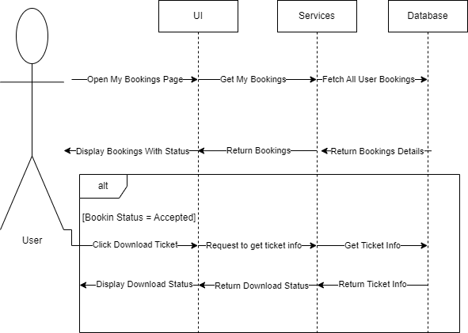

* Give Feedback

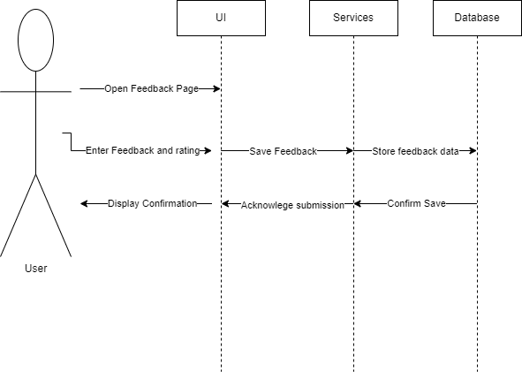

* View / Add Users

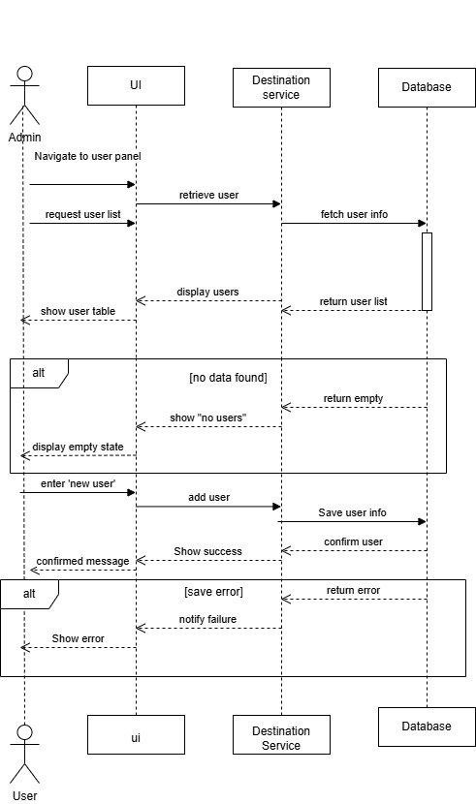

* Trip Management

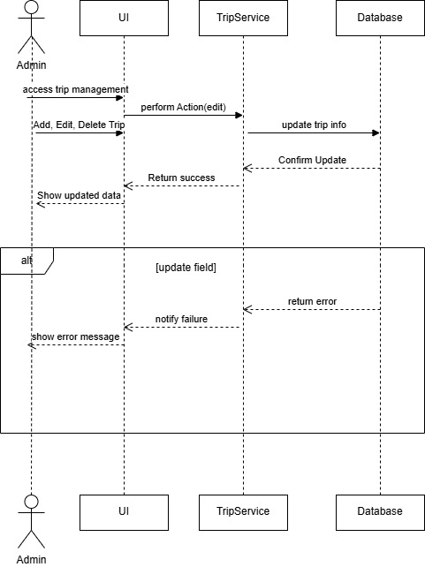

* Destination Management

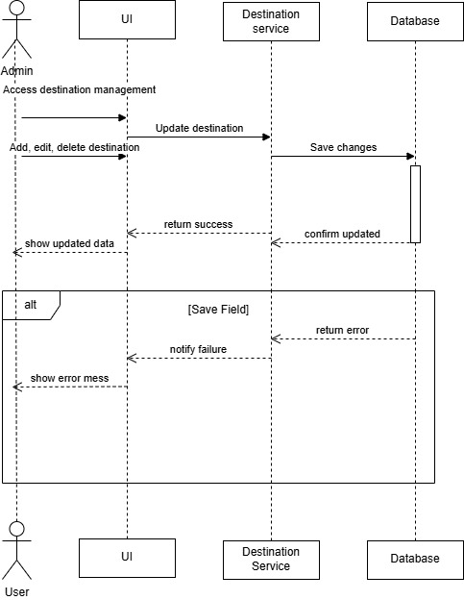

* Booking Request Process

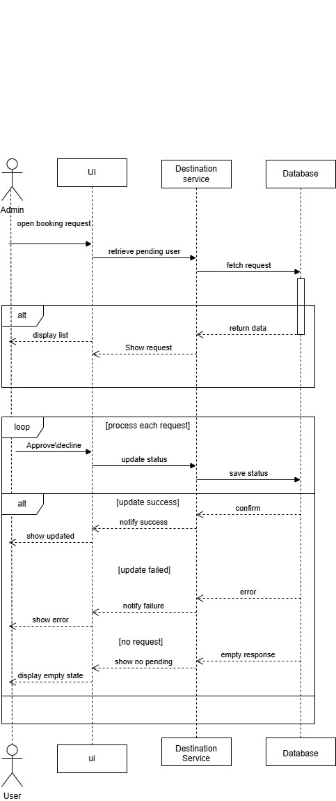

* Generate Ticket PDF

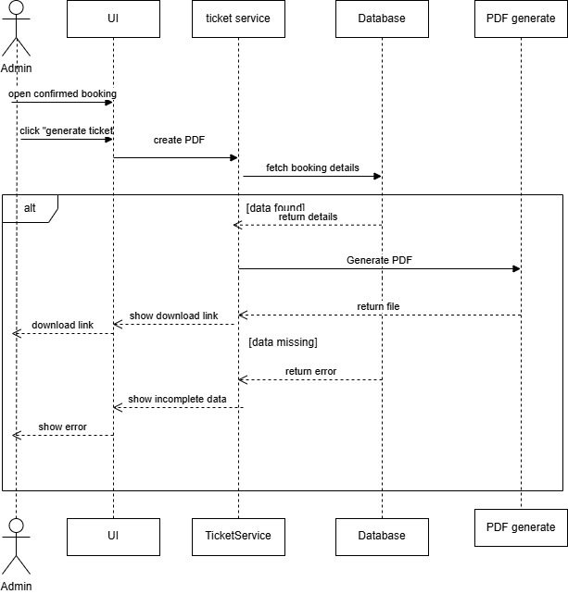

* Change Booking Status

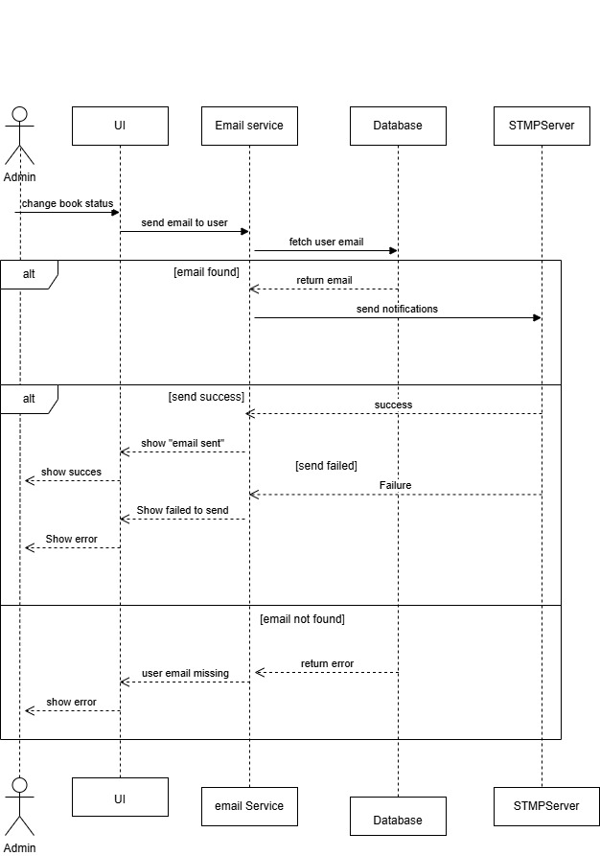

* View Feedback

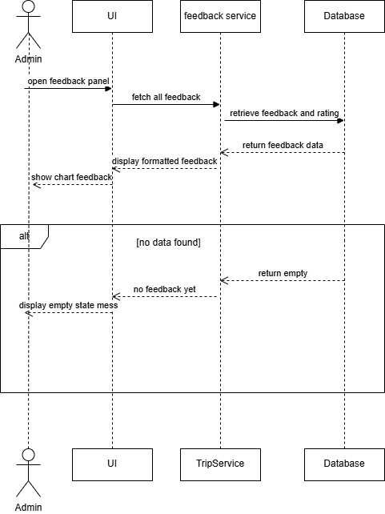

**4 - UI/UX Design**

**--------------------------------**

**Traveler Interface**

* **Sign in**

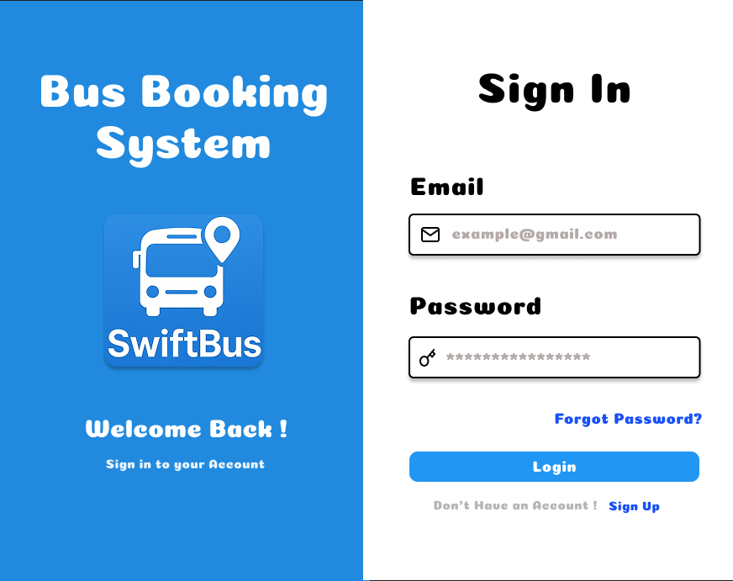

**Traveler Interface**

* **Sign Up**

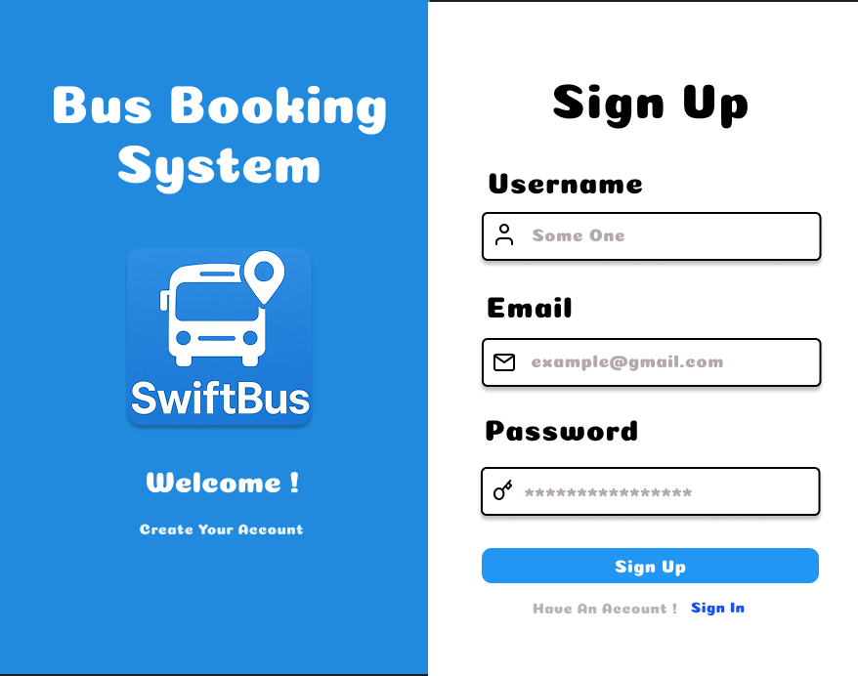

**Traveler Interface**

* **Reset Password**

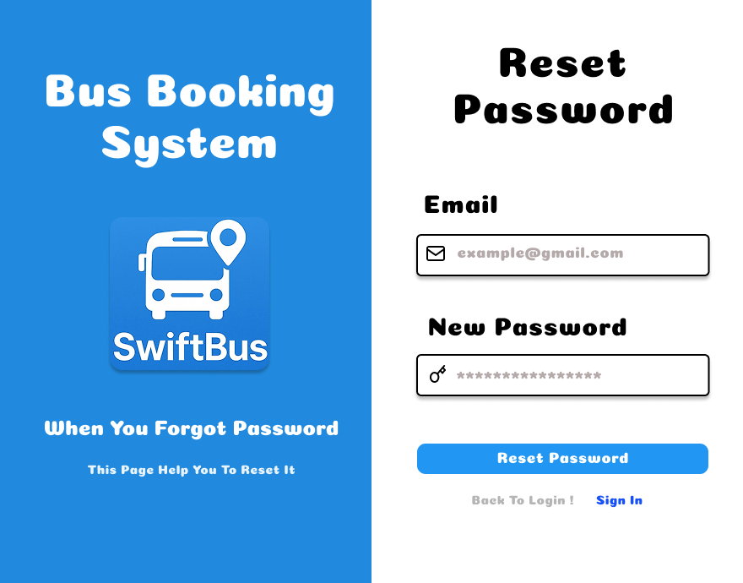

**Traveler Interface**

* **Home**

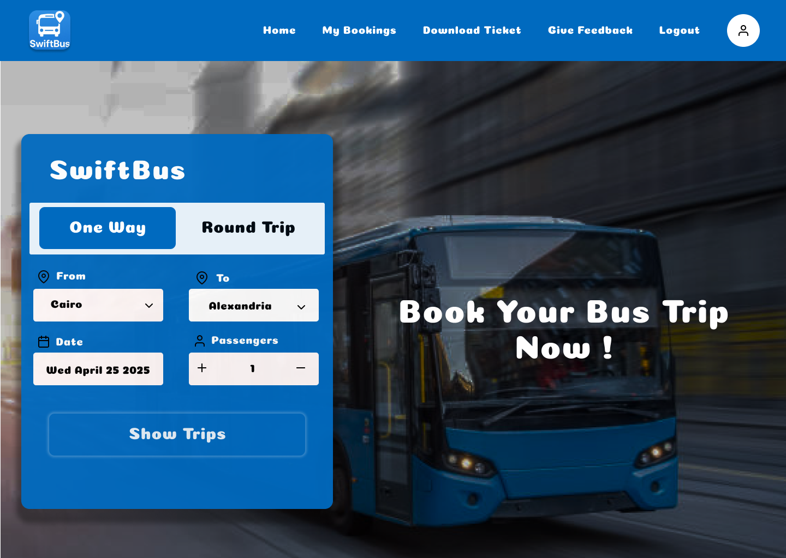

**Traveler Interface**

* **Available Trips**

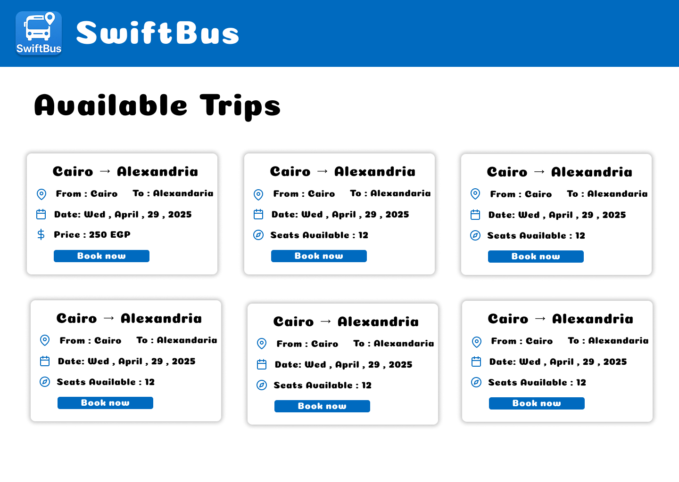

**Traveler Interface**

* **Payment Dialog**

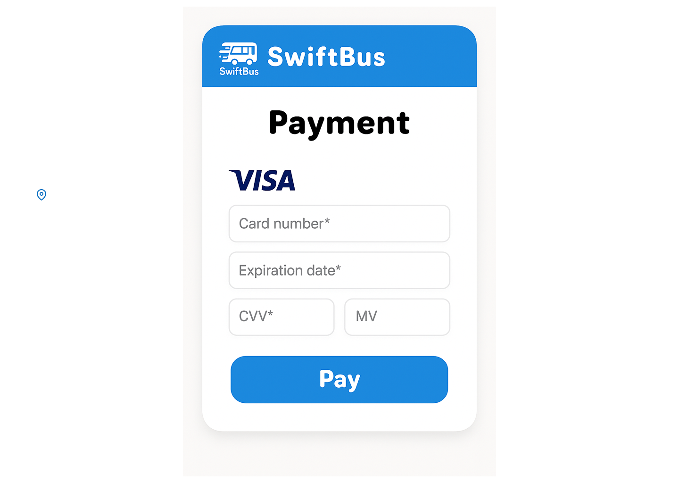

**Traveler Interface**

* **My Bookings**

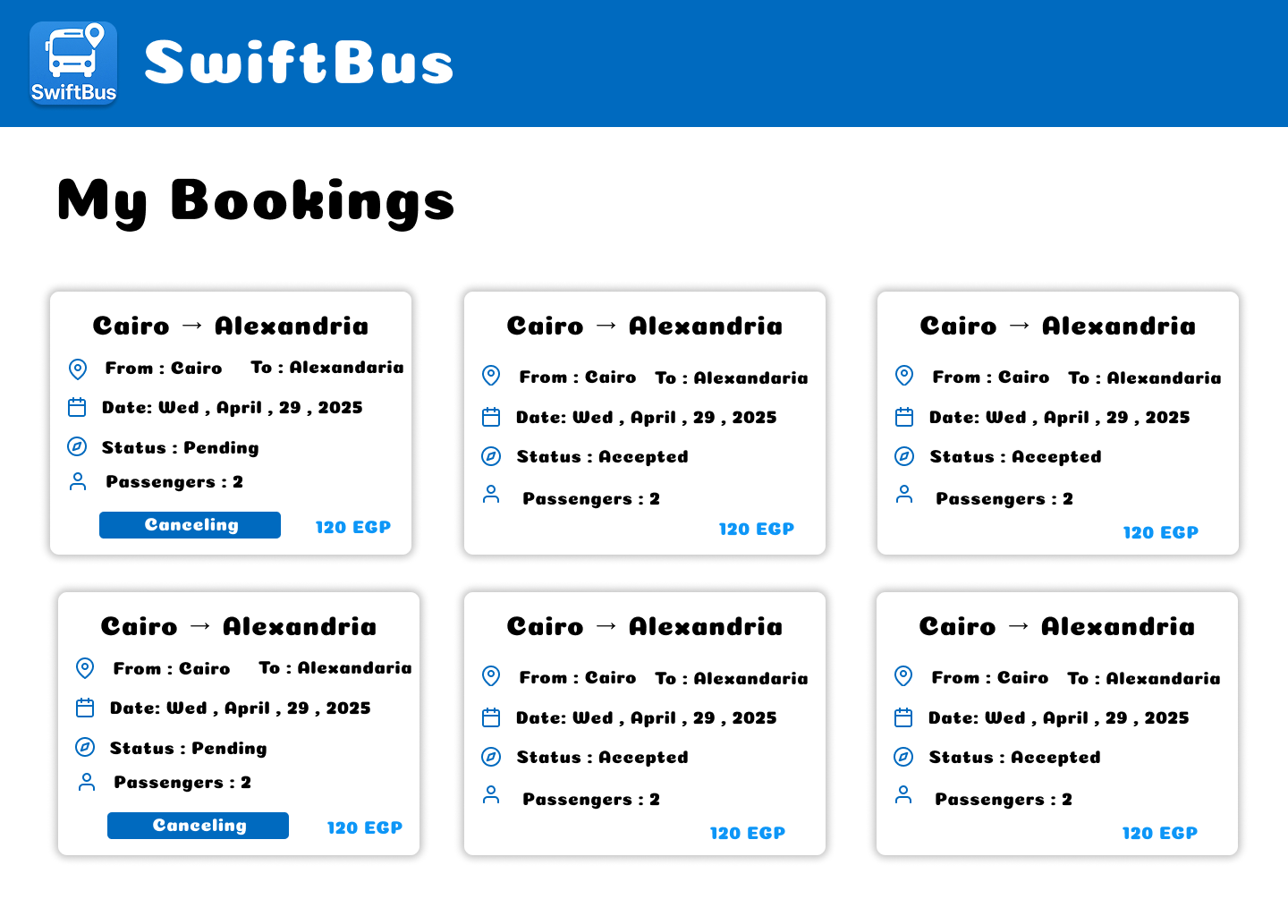

**Traveler Interface**

* **Download Tickets**

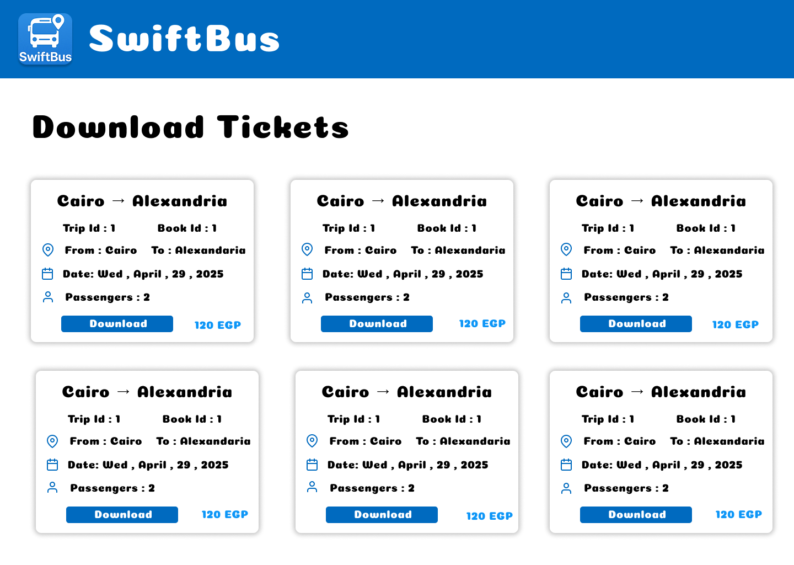

**Traveler Interface**

* **Give Feedback**

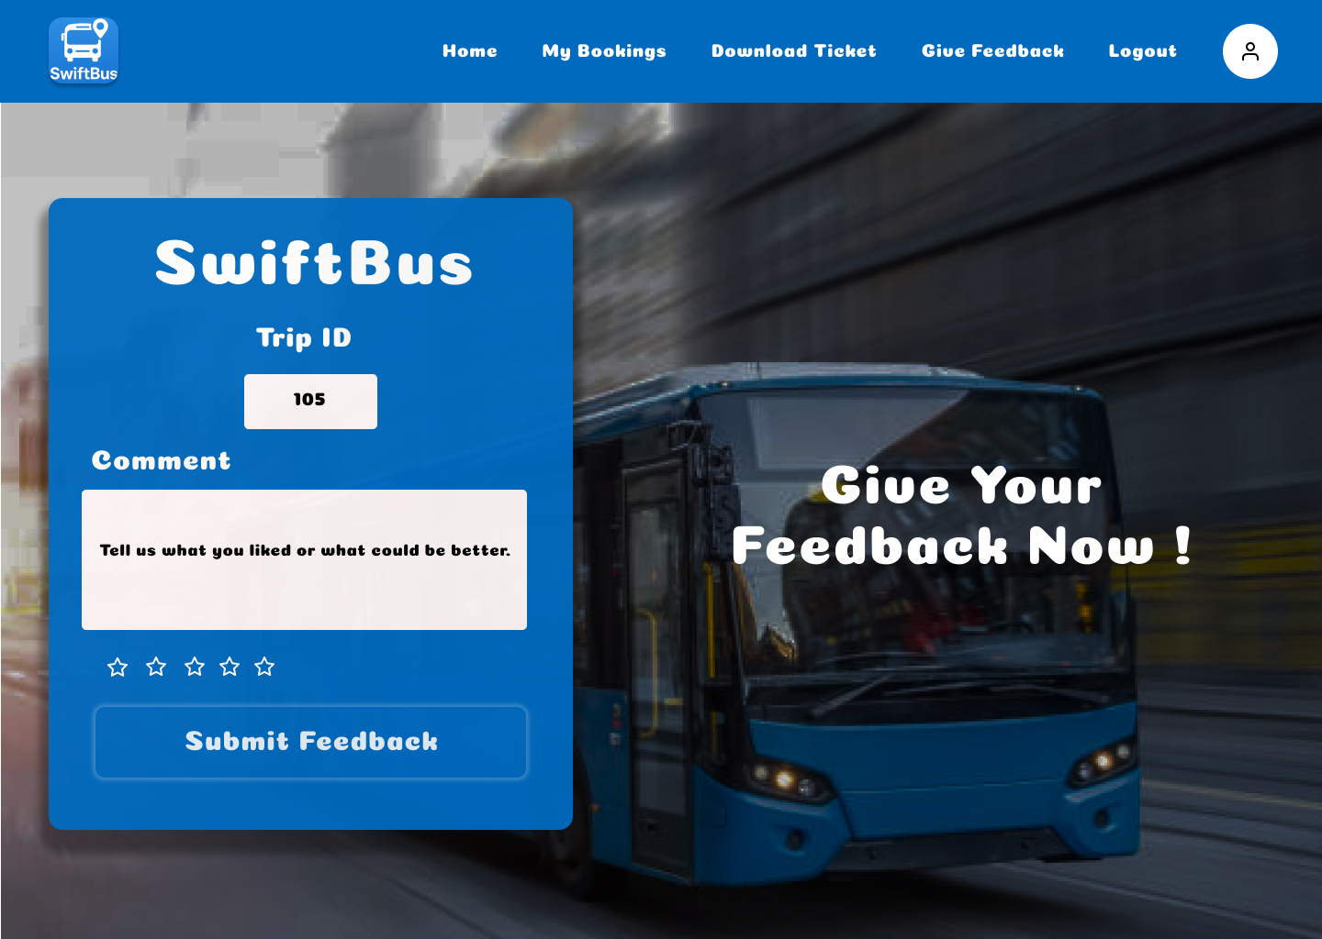

**Admin Interface**

* **Admin Dashboard**

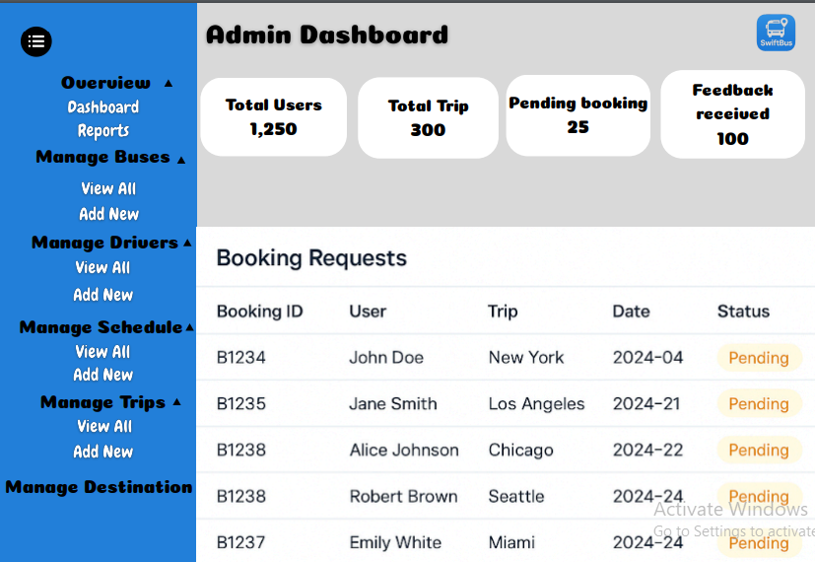

**Admin Interface**

* **Report Page**

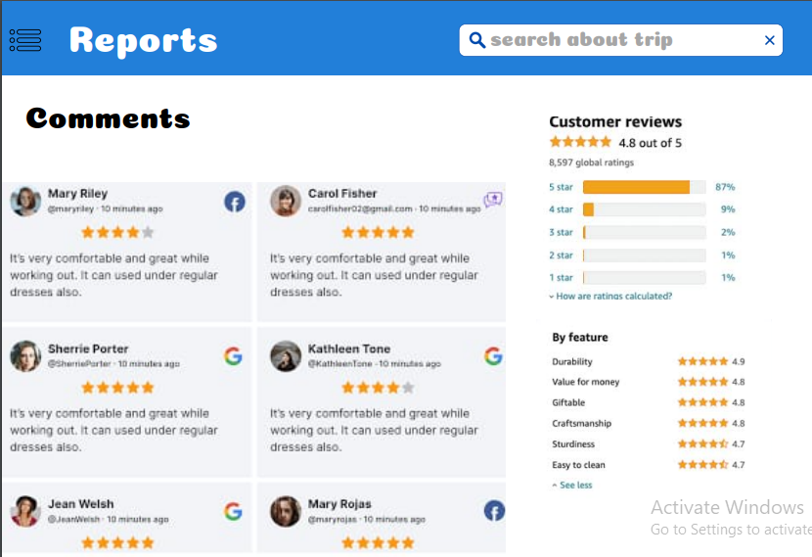

**Admin Interface**

* **Manage Buses (view all)**

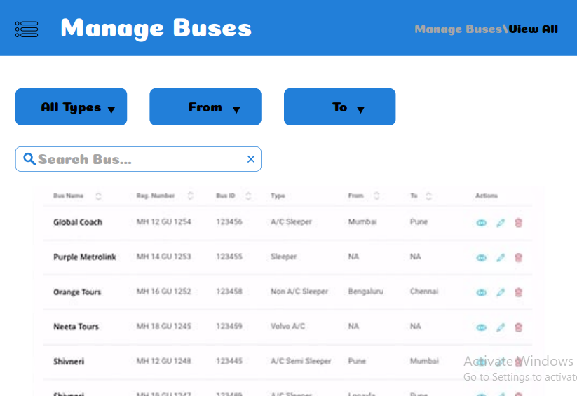

**Admin Interface**

* **Manage Buses (Add new)**

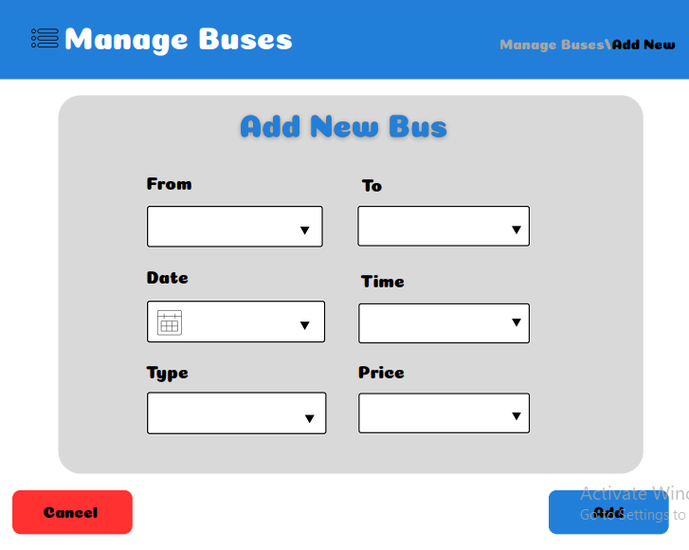

**Admin Interface**

* **Manage Drivers (view all)**

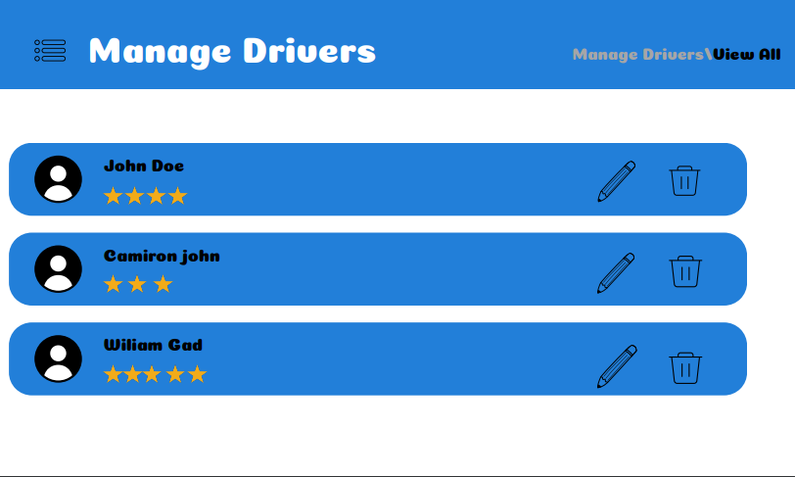

**Admin Interface**

* **Manage Drivers (add new)**

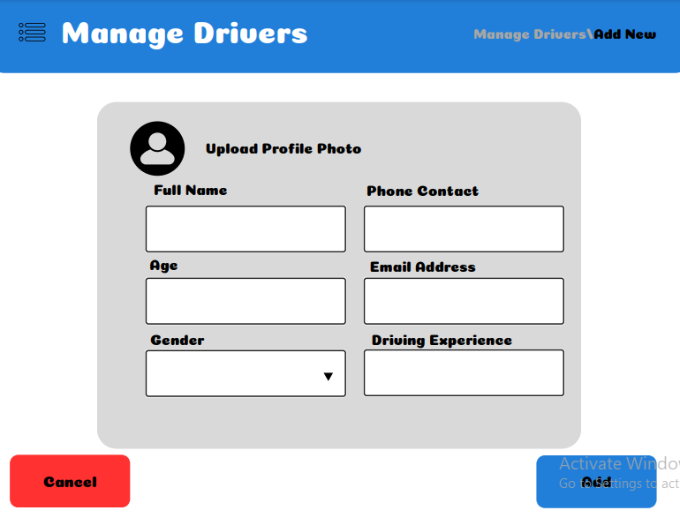

**Admin Interface**

* **Manage Drivers(edit info)**

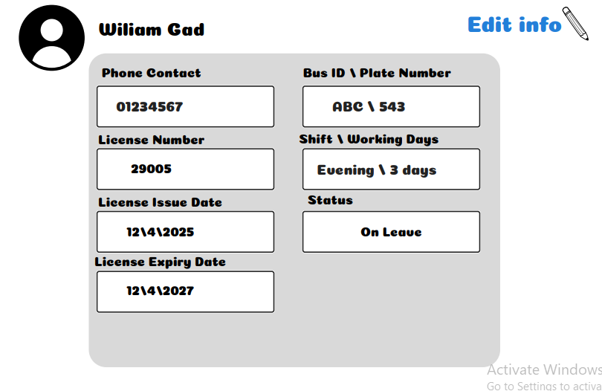

**Admin Interface**

* **Manage Schedule**

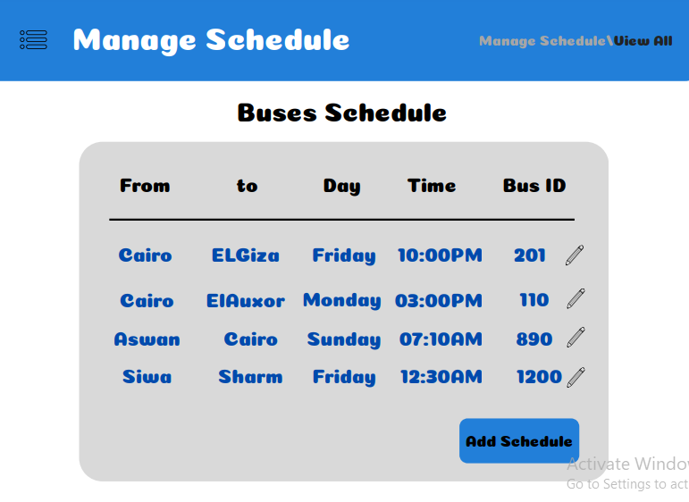

**Admin Interface**

* **Manage trips (view all)**

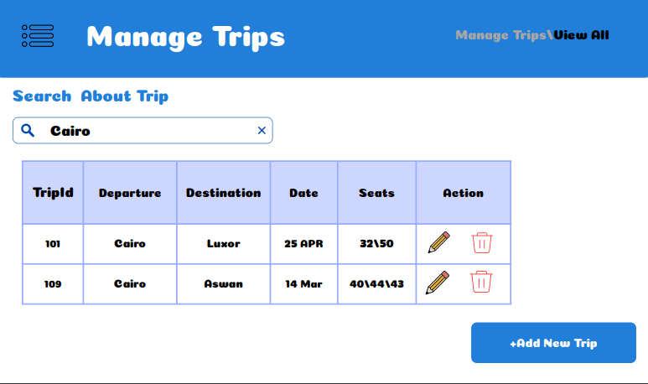

**Admin Interface**

* **Manage Trips (add new)**

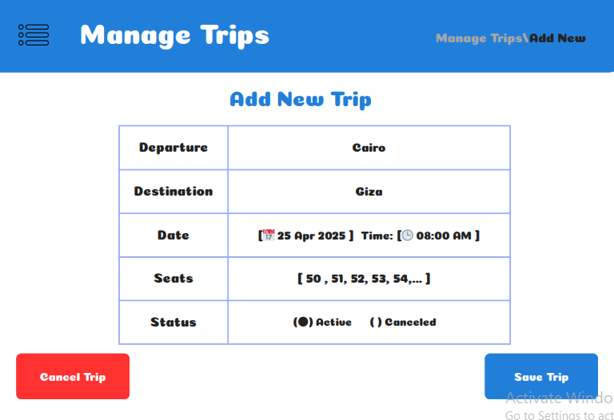

**Admin Interface**

* **Manage Destination**

